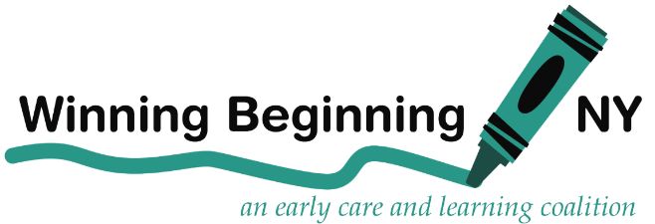
Empire State Campaign
for Child Care

MEDIA ADVISORY

FOR IMMEDIATE RELEASE
CONTACT: Dede Hill, 518-879-6616 or Jenn O’Connor, 518-817-1107
March 30, 2020

EMERGENCY FUNDS IMPERATIVE TO SUPPORT CHILD CARE PROGRAMS AND THE FAMILIES OF ESSENTIAL WORKERS

Child care providers—largely women- and minority-owned small businesses—are on the frontlines of the COVID-19 crisis. They need funding in the 2020-21 Budget, currently under discussion, to continue to provide safe care to children across the State, especially the children of first responders and essential staff.

While thankful for the guidance of regional Child Care Resource and Referral (CCR&Rs) agencies, the NYS Office of Children and Family Services (OCFS), and the NYS Department of Health, conditions are changing every hour and resources are scarce. Providers do not have the funds to continue to do their jobs safely, and are worried that if they are forced to close programs they will never re-open.

New York’s health crisis is expected to peak in two to three weeks. Schools, which often provide care for school-aged children, are closed at least until April 15th. We predict that essential workers will be needed to work at full tilt for at least the next six weeks. Many of these workers have young children who need care and supervision so they can work. With schools closed, and the public health crisis making it unsafe to leave children in the care of older relatives or friends, it is imperative that New York provide these families with the child care they need.

New York State must:

1. Issue a mandatory order that child care programs may only provide care for the children of first responders and essential workers, children experiencing homelessness, and families involved in the child welfare system; that this care be provided without cost to parents; and that New York, using emergency federal and state funds, will cover all costs. Implementing this order should be led and coordinated by OCFS with regional CCR&Rs.

2. Provide clear guidance – updated regularly – on how to provide care in the safest manner possible during the COVID-19 public health emergency, for those child care providers that choose to remain open to care for the children of essential workers, children experiencing homelessness, and families involved in the child welfare system (hereinafter, “emergency child care providers,” or “ECCPs”).

3. Encourage and resource ECCPs to provide extended care – before and after normal business hours – to accommodate the extended hours many essential workers are being required to work to address the public health emergency.

4. Provide premium pay and access to comprehensive health care, including mental health coverage, to all ECCPs, their staff and the staff of agencies that directly support providers.

5. Direct local department of social services (DSSs)/Administration for Children’s Services in New York City (ACS) in New York City to pay all providers participating in the child care subsidy program for March and April 2020 based on the number of children enrolled as of March 1, regardless of attendance.

6. Enable providers to apply for grants to cover the costs of private pay tuition from families unable or unwilling to pay during this period of emergency – to be paid out from the COVID-19 Child Care Emergency Fund.

7. Direct and resource all providers – whether they provide care during the period of emergency to undertake reasonable efforts to engage in virtual home visits or other check-ins with the families in their programs.

8. Allow afterschool programs with state-funded afterschool contracts, specifically Advantage After School Program, Empire State After-School Program, and Extended School Day, and federally-funded 21st Century Community Learning Centers Programs to pay their staff with contracted funds during school and program closures.

9. Cover these costs by creating a flexible COVID-19 Emergency Child Care fund in the 2020-2021 Budget. Some or all of these funds could be derived from a portion of workforce development / economic development funds directed to child care, as well as from more than $150 million in new federal Child Care and Development Block Grant (CCDBG) funds expected to be allocated under the latest federal relief package – the CARES Act.

